3D Printed Grating Mount

Assembly Protocol

**Parts List**

3D Printed Parts Required

* Grating base (File name: Gratin Base)
* Assembly base (File name: Assembly Base)
* Alignment plate (File name: alignment plate)
* Adjustment screw cap (File name: adjustment screw Cap)
* Adjustment screw mount (File name: screwmount)
* Structural Base (File name: Structure.)

Optics Parts

* Thorlabs LDM21 laser mount
* Diode of choice
* 2x Thorlabs F25USN1P + F25US050 adjustment screws and brushings.
* Thorlabs GR13 – 1850 optical grating
* Mirror
* Thorlabs optical post system.
* Thorlabs PK4DLP2 Piezoelectric device

Tools & Materials

* 2-56, 4-40, 8-32 taps
* 3x 2-56 screws at least ½ inch in length
* 3x 4-40 ~ ¼ inch long screws
* 8-32 at least½ inch long screw
* Epoxy, superglue, or other high strength adhesive
* tacky wax
* Small ~ ¼ inch long spring

**Assembly**

1. Remove 3D printed supports on the grating base with a small flathead screwdriver or needle nose pliers. Remove all pieces shown in red. This step is not necessary if you are able to use supports that can be easily eliminated.

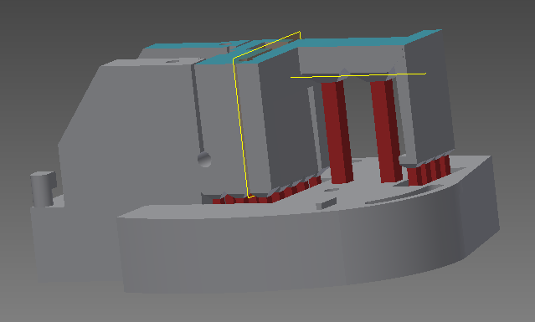 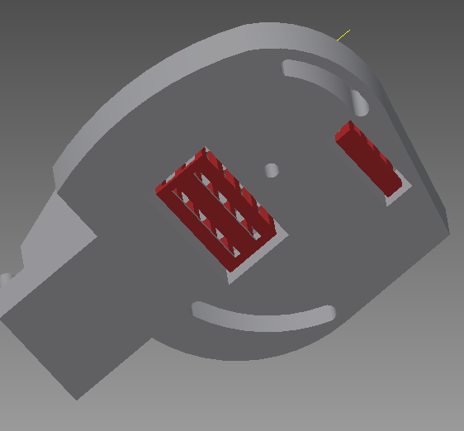

1. Tap holes as needed. There are three 4-40 holes in the grating base that need to be tapped. The two on top are for securing the adjustment screw cap. And the one on the side is for securing the piezo in place

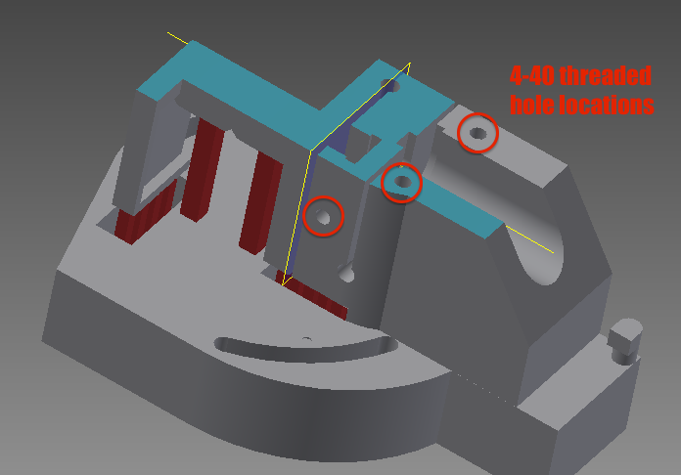

1. Tap the hole 4-40 hole as indicated by the arrow and insert the 4-40 screw to be used to attach one side of the adjustment spring.

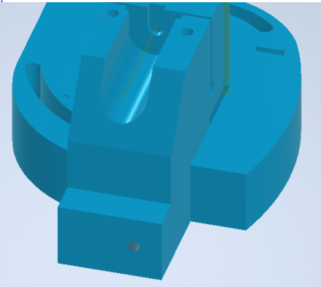

1. Tap two 4-40 holes (red) for into the mounting base for locking the grating base into position. Tap two addition 8-32 holes (blue) for the mounting of pedestal mounts or other method of securing the base to an optical table.

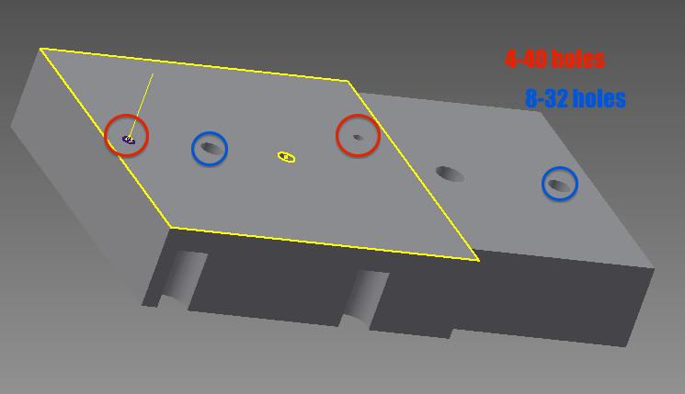

1. Tap the 4-40 hole on the screw mount assmebly as indicated by the arrow. Insert the 4-40 screw. This screw will be the anchor for the spring that allows for course adjustment of the grating base.

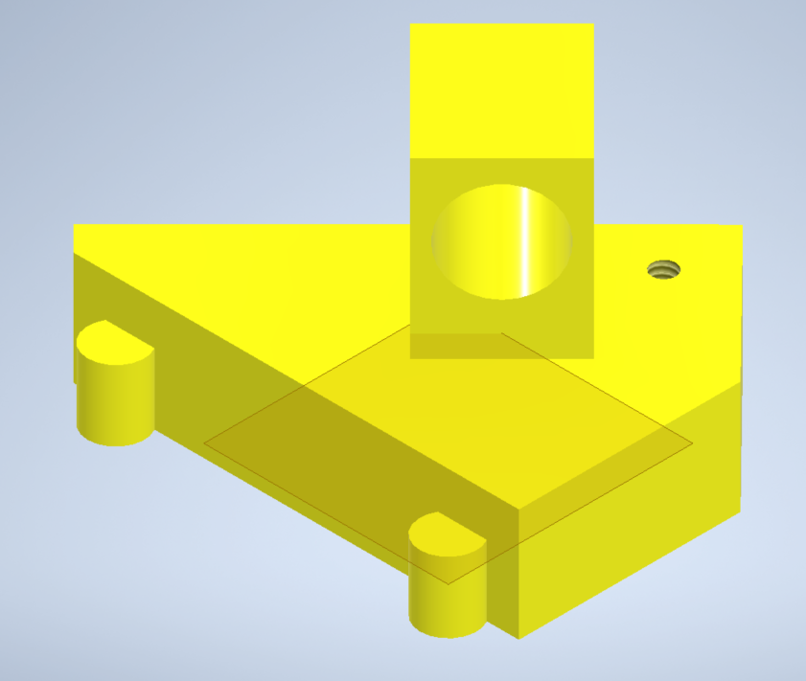

1. Adhere the screw mount assembly to the assembly base, following the instructions on the chosen adhesive. Align the pieces by placing the rounded extrusions on the screw mount into the appropriately shaped mating features in the assembly base. Attempt to adhere them such that a flush, level surface is formed.

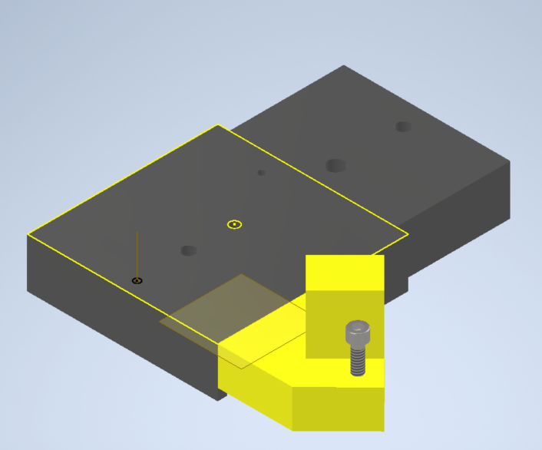

1. Using the adhesive, adhere one of the 2-56 screws into the middle 2-56 hole in the assembly base (It is sized for clearance rather than threading, so the screw goes all the way through. The screw will act as a pivot for the grating base.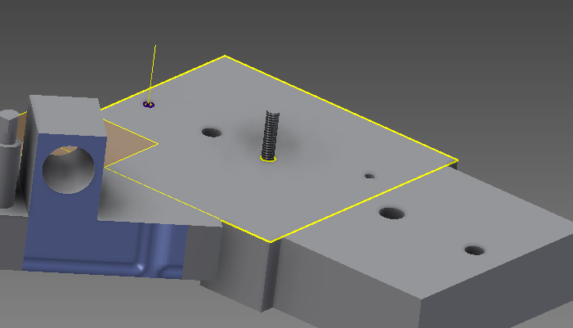
2. Insert and secure the adjustment screw housing from the inside out as show below. This allows the house to have continuously applied pressure keeping it set. If the fit is a bit loose one may use adhesive or a soldering iron to heat the housing so it melts the PLA and sets in place.

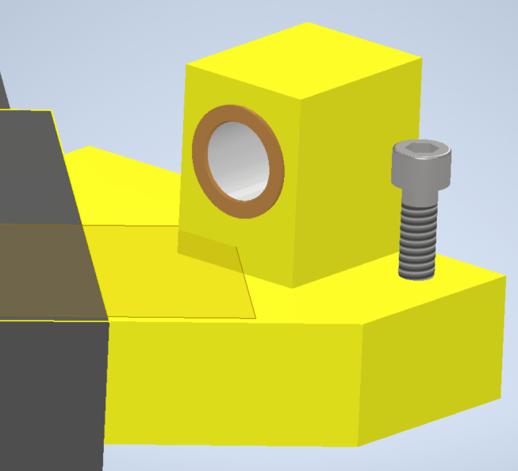

The other adjustment screw housing is placed in the appropriately sized place in the grating base, such that the screw is flush against the portion of the part which will hold the optical grating and mirror. Secure the grating base adjustment screw with the Adjustment screw cap and two 4-40 screws.

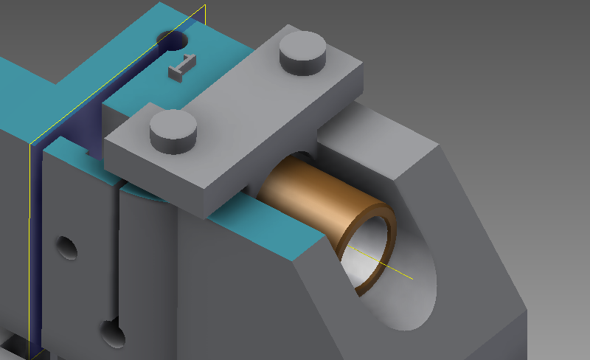

1. Insert the piezoelectric device into the appropriate slot and carefully secure with a 4-40 screw. One could use a nylon tipped screw here if there are exposed piezo contacts. Make sure the device is flat against the bottom of the slot, with wires to the side.

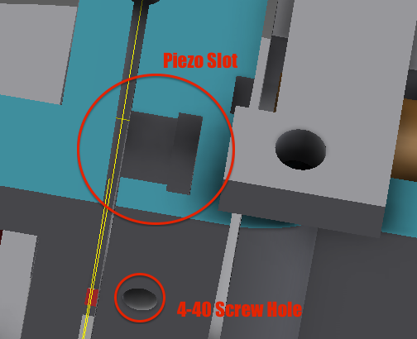

1. Using tacky wax or another temporary adhesive place the grating and the mirror in their appropriate locations. When the alignment is perfect, use the adhesive to secure their position as indicated by the red arrows (on the side that cannot be seen as) using as little glue as possible. Treat the adhesion as permanent, but by gluing along the side, as opposed to the back, removal of the grating is possible with a sharp blade.

Grating location:

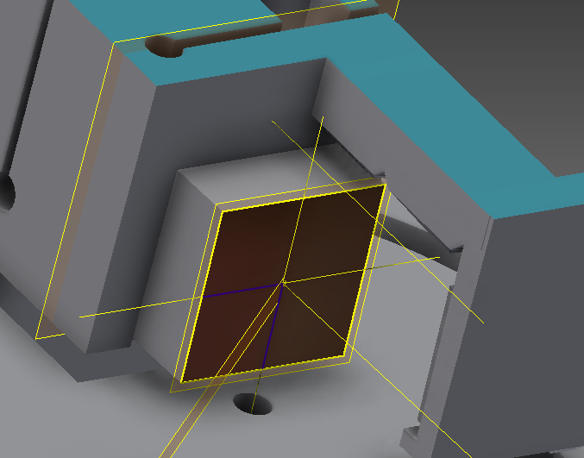

Mirror location:

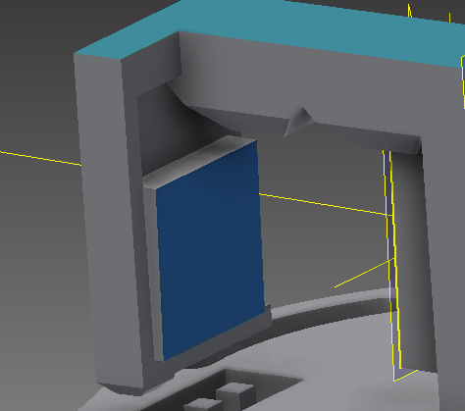

1. Place the grating base on the assembly base, insert the two 2-56 screws through the slots in the grating base and into the appropriate holes in the assembly base, and hook the spring to the two posts provided.

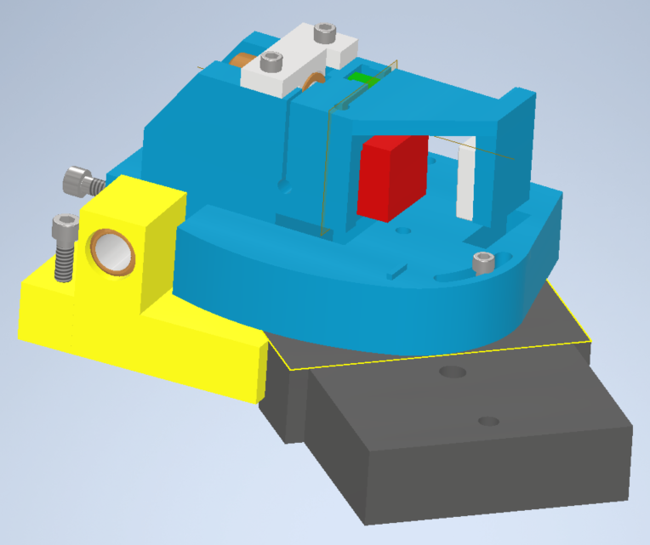

Spring location: Attach a suitable spring here such that there is constant pressure on the ¼-100 screw used for angle adjustment.

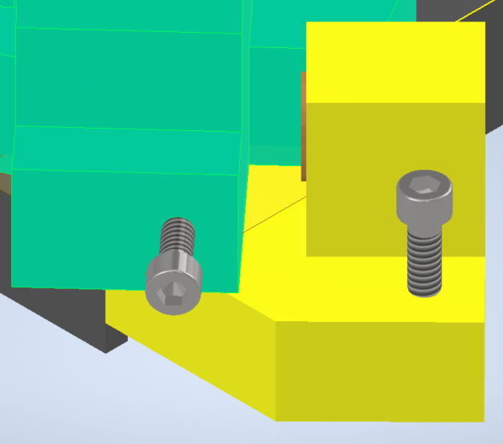

1. Attach the alignment plate to the appropriate place on the LDM21

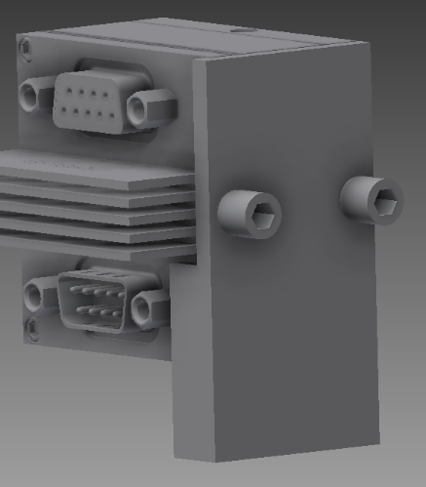

1. Mount the LDM21 using the 8-32 screw through the clearance hole in the assembly base. The alignment plate insures that the diode is oriented the right way as the screw is tightened to hold it in place. (Grating base is removed to show detail of mounting).

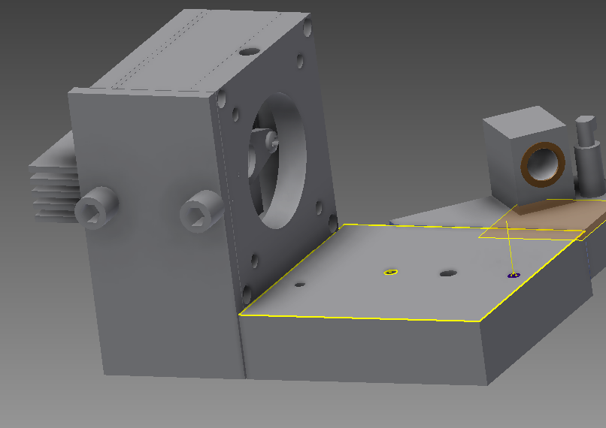

1. Mount the assembled structure to an optics table using the optical posts or alternate method. These posts can be screwed into the two 8-32 holes in the base. The optical posts are then mounted to an optical table.